[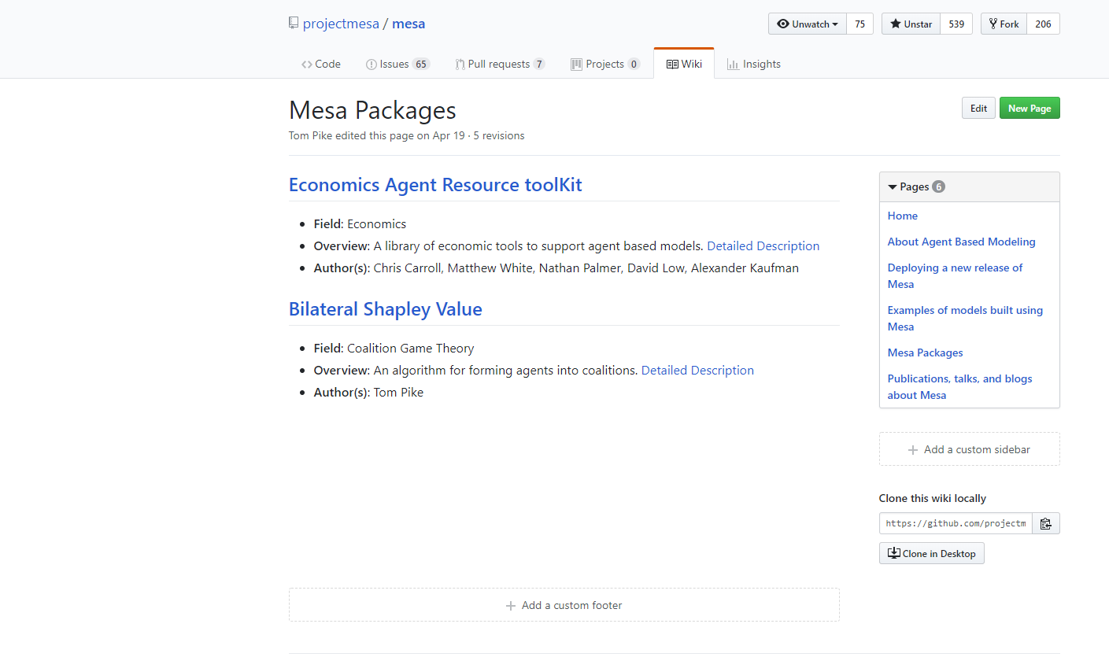](https://github.com/projectmesa/mesa/wiki/Mesa-Packages)[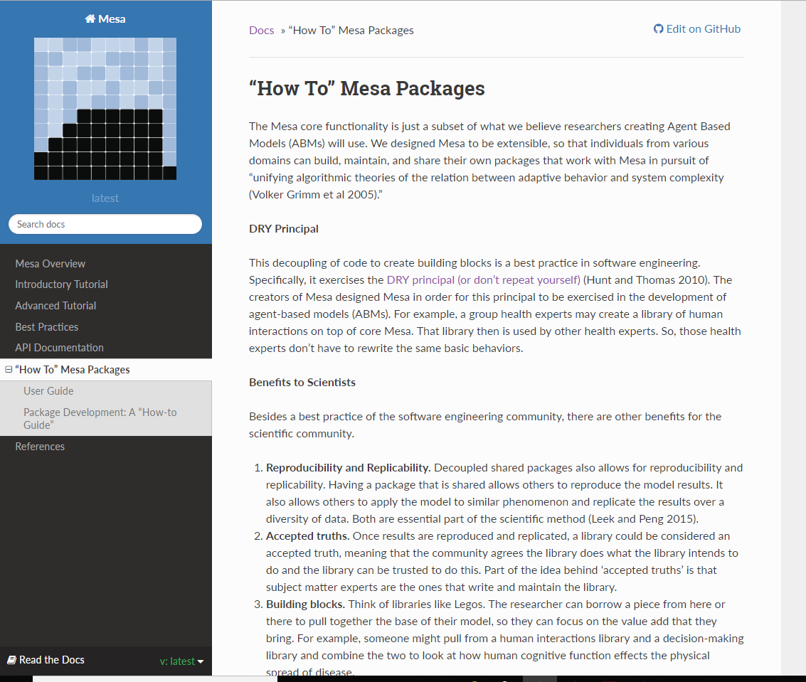](http://mesa.readthedocs.io/en/latest/packages.html)

**Figure 1:** (left) Mesa Packages Repository Page <https://github.com/projectmesa/mesa/wiki/Mesa-Packages> (right) Mesa Packages Tutorial Page <http://mesa.readthedocs.io/en/latest/packages.html>

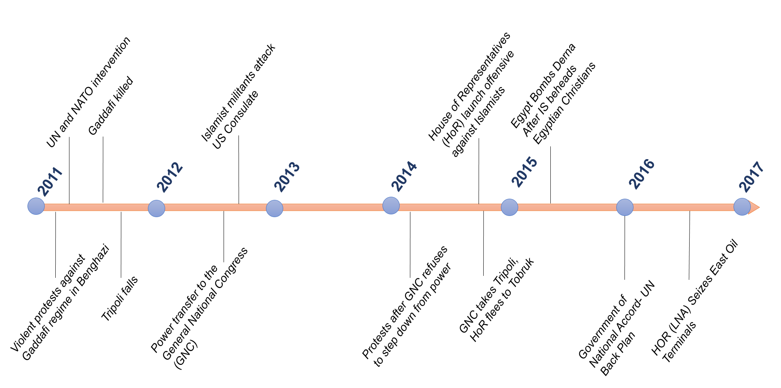

**Figure 2**: Timeline of events in Libya

(Sources: Boduszyński, 2015; “Libya profile - Timeline - BBC News,” 2017)

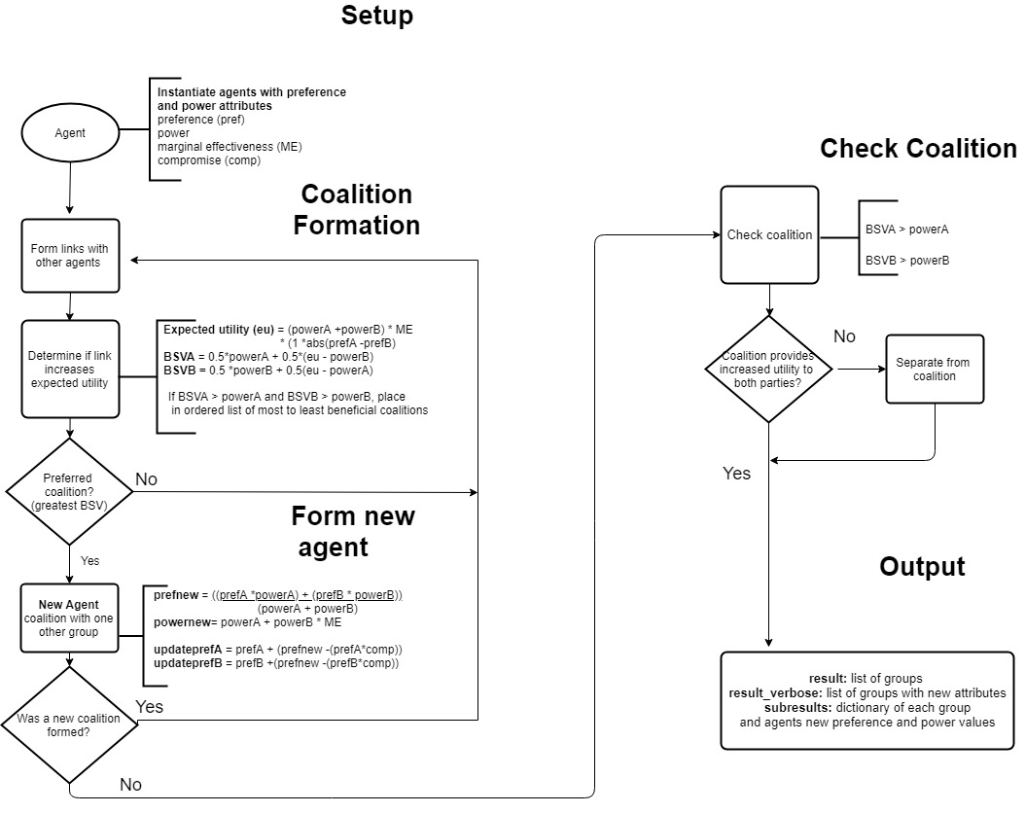

**Figure 3**: Flow Diagram of Computational Model

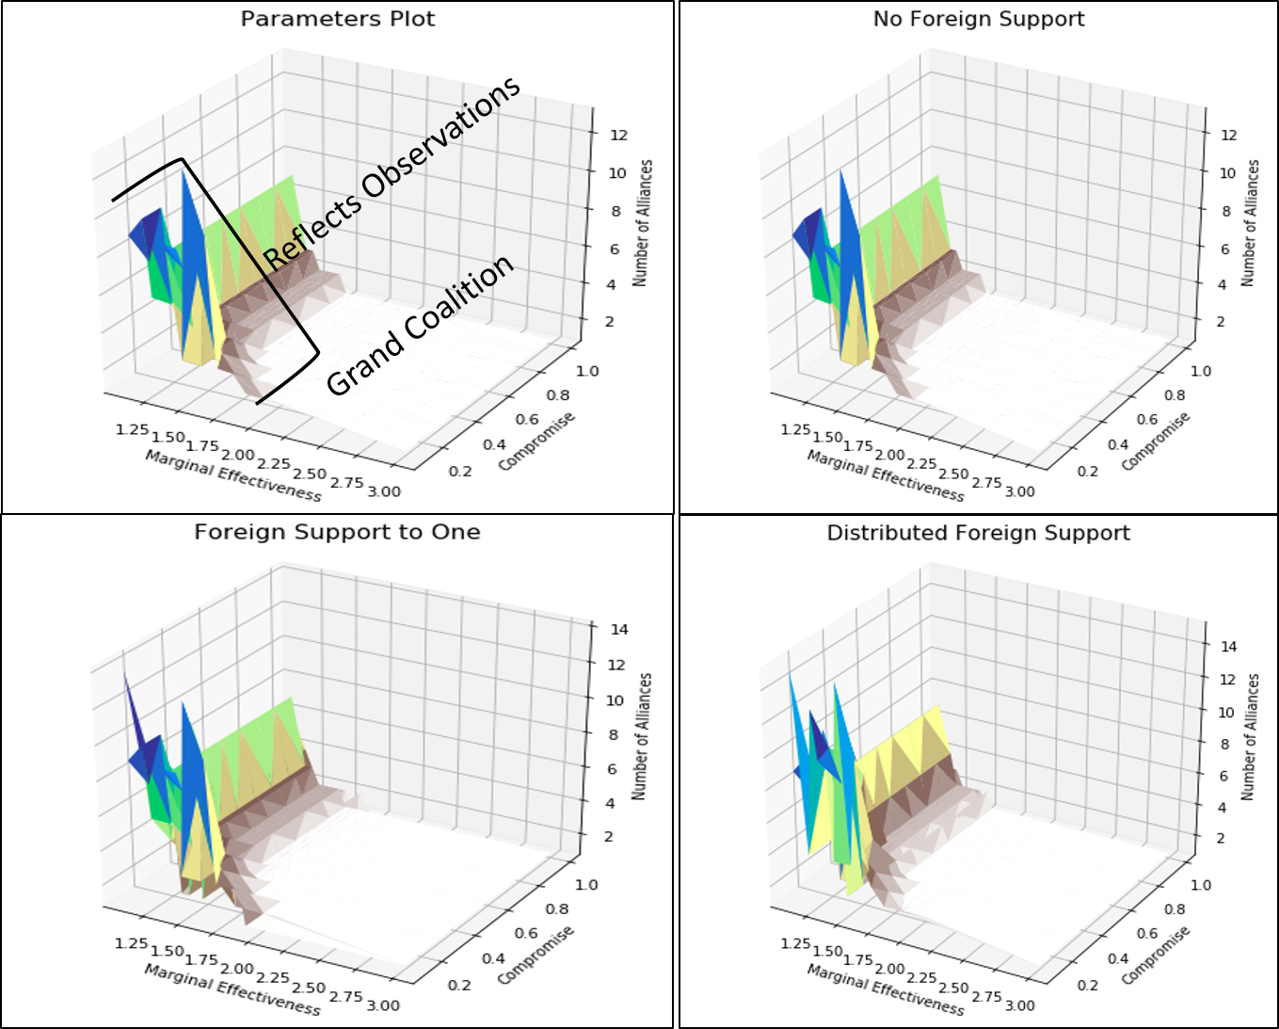

**Figure 4**: Plots of parameter impact on coalition formation (upper left) general description of results using no foreign support (upper right) coalition formation with no foreign support (bottom left) coalition formation with support to one group (bottom right) coalition formation with foreign support distributed to three groups. Color was used to show relief in plot, but has no additional significance.

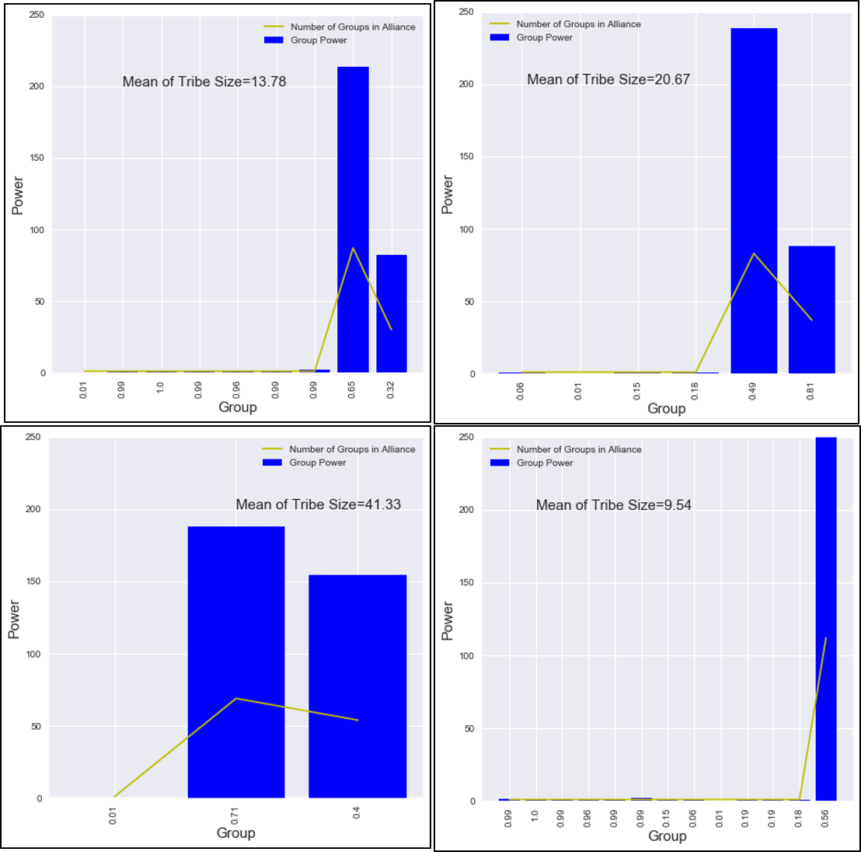

**Figure 5**: Impact on the majority agent preference (ideology) with a compromise parameter of 0.1 and varying marginal effectiveness parameters. (top left) Marginal effectiveness of 1.3, more fundamentalist majority - 0.65 preference. (top right) Marginal effectiveness of 1.4, more moderate majority - 0.49 preference. (bottom left) Marginal effectiveness of 1.45, more fundamentalist majority - 0.71 preference. (bottom right) Marginal effectiveness of 1.5, moderate majority, near grand coalition - 0.56 preference. Mean of tribe size is the average number of groups within the coalitions.

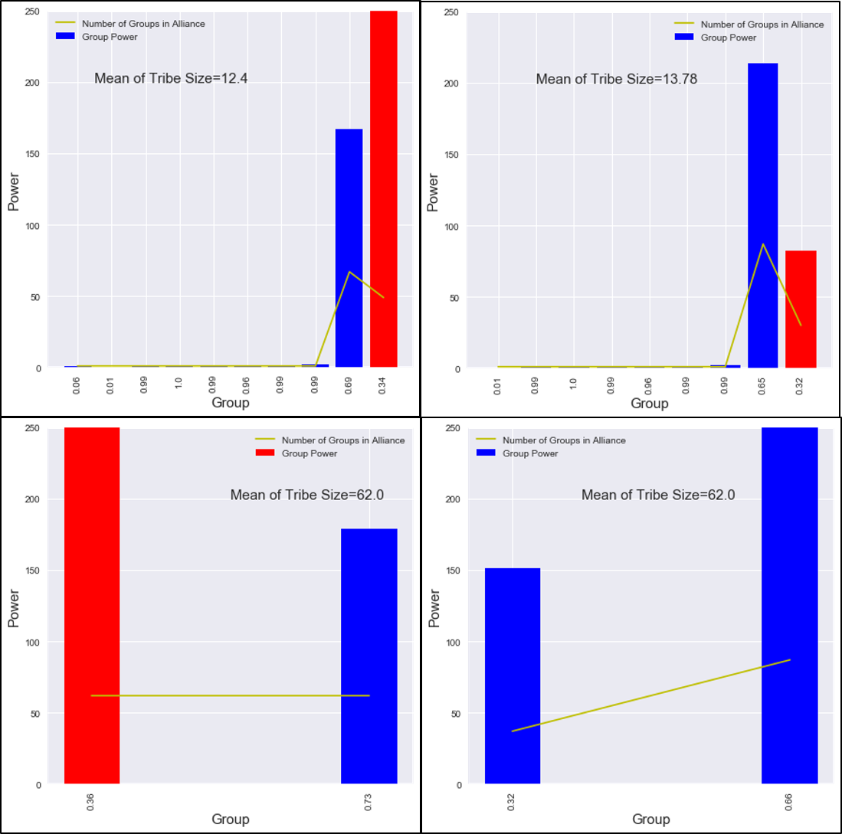

**Figure 6:** Impact of a foreign support (upper left) Major support (al-Ubaidat- red coalition) to one group with a 0.1 compromise parameter and a 1.3 marginal effectiveness. (upper right) Major support to one group (al-Ubaidat- red coalition) with a compromise parameter of 0.1 and a marginal effectiveness of 1.4. (bottom left) Major support to one group (al-Ubaidat- red coalition) with a compromise parameter of 0.1 and a marginal effectiveness of 1.5. (bottom right) Major support to three groups with a compromise parameter of 0.1 and a marginal effectiveness of 1.5. Mean of tribe size is the average number of groups within the coalitions.